SmartCare v0.4 - Domain Implementation Workbook
Week 7 student resource

1. UML-to-Code Trace
UML element | Python element | Implemented? | Notes
Patient class | class Patient | Yes | Core domain class from the approved design.
Patient attributes | patient_id, name, contact_details | Yes | Stored on the object; ID and name are validated.
Patient operations | update_details(), get_details() | Yes | Implements the approved patient responsibilities.
Practitioner class / attributes | class Practitioner; practitioner_id, name, specialty | Yes | specialty is included as required in Stage 4.
Practitioner operation | update_details() | Yes | Updates name and specialty with validation.
Practitioner schedule visibility | Derived from linked appointments | Partial | No separate schedule/database object is added; schedule remains derivable from appointments.
Appointment attributes | appointment_id, patient, practitioner, appointment_time, status | Yes | status is exposed read-only and stored internally as _status.
Appointment operations | update(), cancel(), change_status() | Yes | All three UML operations are implemented.
Patient/Practitioner associations | Appointment.patient; Appointment.practitioner | Yes | Each Appointment stores exactly one reference to each; either can be linked to many appointments.
Appointment status type | AppointmentStatus enum | Yes | Uses SCHEDULED and CANCELLED for the verified behaviour.

2. Domain Invariants
Class | Invariant / rule | How protected
Patient | patient_id and name must not be blank. | Constructor/update validation raises ValueError for blank required values.
Practitioner | practitioner_id, name and specialty must not be blank. | Constructor/update validation raises ValueError.
Appointment | Each appointment must reference one Patient and one Practitioner. | Both references are required constructor arguments and stored on the Appointment.
Appointment | appointment_id cannot be blank and appointment_time must be a datetime. | Constructor checks the ID and type; update() also checks datetime.
Appointment | A new appointment starts as SCHEDULED. | __init__ sets _status to AppointmentStatus.SCHEDULED.
Appointment | Status changes are controlled; a cancelled appointment remains an object and cannot transition again. | Read-only status property plus cancel()/change_status(); repeated cancellation raises ValueError.

3. Composition / Inheritance Decisions
Relationship | Decision | Rationale
Appointment - Patient | Association, not inheritance/composition | A Patient exists independently and may be linked to 0..* Appointments.
Appointment - Practitioner | Association, not inheritance/composition | A Practitioner exists independently and may be linked to 0..* Appointments.
Patient - Practitioner | No direct relationship added | The approved model connects them through Appointment; adding a direct link would invent a dependency.
Patient / Practitioner / Appointment | No inheritance | The three classes represent different domain concepts and do not form an is-a hierarchy.
Appointment - AppointmentStatus | Enum/value dependency | Appointment uses the enum to restrict status values; it is not a superclass or composed domain object.

4. AI Pair-Programming Record
AI contribution | Conforms? | Decision | Reason | Verification
AppointmentStatus enum; default SCHEDULED | Yes | Accept | Matches the Stage 4 constraint and keeps status values explicit. | Manual check: a new Appointment reports SCHEDULED.
Private _status + read-only status property | Yes | Accept | Prevents uncontrolled public status assignment while representing the UML status. | Code review confirms there is no public status setter.
cancel() and change_status() transition rules | Yes | Accept | Allows SCHEDULED -> CANCELLED and rejects illegal/repeated transitions. | Manual check: cancel gives CANCELLED; second cancel raises ValueError.
update() changes appointment_time | Yes | Accept | Reasonable interpretation of UML update() without changing unrelated state. | Reviewed against the UML; datetime validation is enforced.
AI claim: class has "exactly" the UML attributes | No | Modify explanation | _status is an extra private implementation detail, even though it backs the UML status value. | Code review confirms _status exists; wording corrected in the lab review.

5. Updated UML
Insert updated UML only if implementation revealed a justified design change. Explain every change.
Completed response
A small v0.4 UML update is justified so the diagram matches the implemented domain layer. Practitioner now includes specialty, and Appointment uses an AppointmentStatus enumeration with SCHEDULED and CANCELLED. The public UML attribute remains status; the private _status field is not shown because it is an implementation detail used to enforce encapsulation. The Patient-Appointment and Practitioner-Appointment multiplicities remain unchanged, and no inheritance, database, UI, notification or service relationships are added.
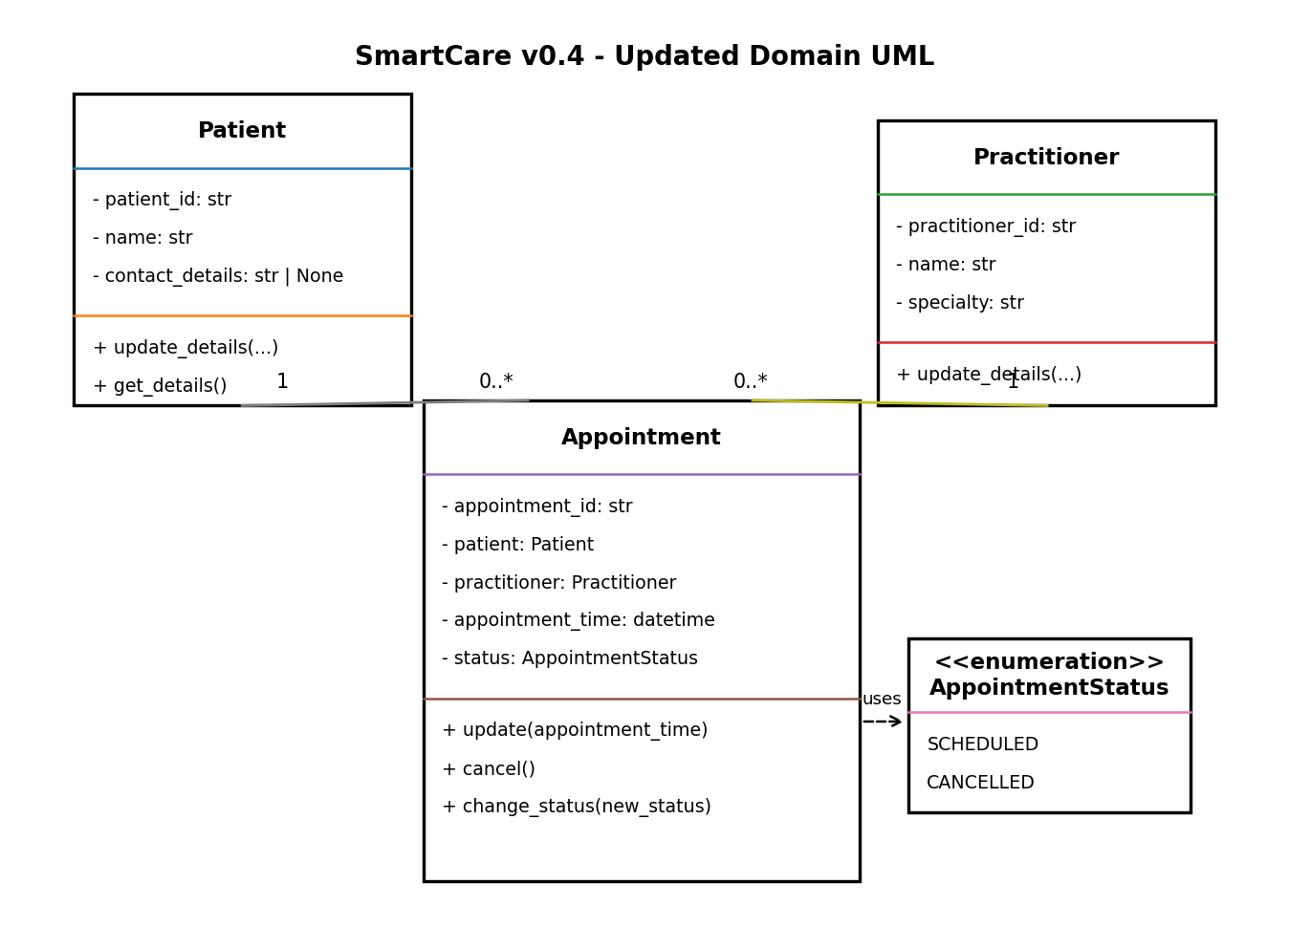
• Practitioner.specialty: Added because the Stage 4 implementation explicitly requires practitioner specialty.
• AppointmentStatus enumeration: Added to make the allowed status values explicit and to support controlled transitions.
• status vs _status: The UML keeps status as the domain attribute. _status is omitted because it is only the private Python backing field.
• Relationships: Patient 1 to 0..* Appointment and Practitioner 1 to 0..* Appointment are retained; no inheritance is introduced.
Trace note: the Stage 4 Practitioner implementation does not add a separate schedule object or database logic. Schedule visibility remains something that can be derived from linked Appointment objects.

